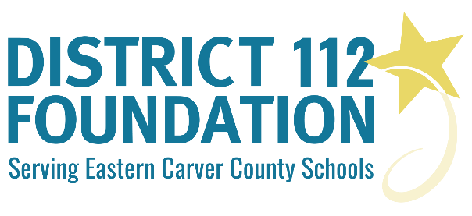

DISTRICT 112 FOUNDATION
EXCELLENCE and INNOVATION in EDUCATION
GRANT GUIDELINES Spring 2019
Who may apply?
Any interested teacher, staff, individual, organization or team of individuals within Eastern Carver County Schools seeking funding for their project may submit a proposal to the District 112 Foundation.

What is the application procedure?
Interested applicants should apply by following these Grant Guidelines and by completing the Grant Application online via the Google form.

What types of projects are eligible for grants?
The District 112 Foundation seeks to fund projects that clearly support our mission: To Advance Innovation and Excellence in Education in Eastern Carver County Schools. Ideally, projects should become self-supporting when the grant period ends. The District 112 Foundation does not fund: teacher prep time, salaries, substitute teachers, tuition, general school supplies, copies, travel, or food/beverage expenses. Grants awarded in the spring are to be expended in the fall semester.

What funding amount can be requested?
The District 112 Foundation will consider grant requests up to $1,500. The grant application should substantiate the proposed grant activities and the budget. Requests above $1,500 or blanket $1,500 requests without details will not be considered.

How are grants awarded?
All complete grant applications will be reviewed by the District 112 Foundation grant committee and they will determine how funds are allocated, based on innovation, sustainability, feasibility and impact on student learning.

What other requirements are there?
The recipients of grant awards will be expected to:
- Complete a written Grant Feedback Form (including photos or videos of your grant project in action).
- Complete a written Grant Financial Summary Report confirming grant fund use.
- Provide feedback on how you will/have shared information on your project and it being funded by the District 112 Foundation. (Examples of sharing in any newsletters, presentations, emails, etc.).
- Assist in sharing and promoting information about grant activities including the possibility of local newspaper interviews, making School Board presentations or other short presentations upon request.

What is the overall timeline for the grant application process?
Grant applications will be considered two times, once in the fall and once in the spring.
For the spring, all applications must be submitted online by April 12th, 2019.
Award notification for fall will take place by May 1st, 2019.
Applicants will be contacted if the grant committee has questions.
Stay tuned for the Fall Grant Application deadline.

