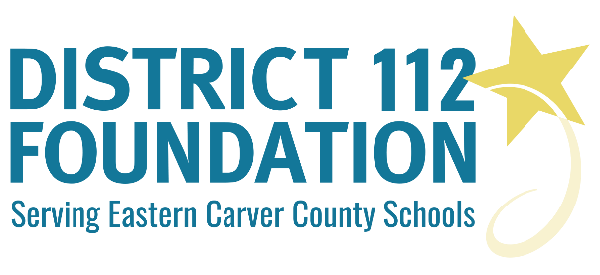

DISTRICT 112 FOUNDATION
EXCELLENCE and INNOVATION in EDUCATION
GRANT APPLICATION OUTLINE 2018-2019

Use this detailed outline to prepare to submit your grant application online via the Google form.

Please be creative and show us the excellence and innovation we can achieve together. Thank you for your time and effort. We look forward to considering your grant application.

Contact Person Email Address:
Primary Contact Person:
Name(s) of Applicant(s):
School Principal or Administrator Email Address: (a copy of grant application will be sent to them for approval)
Location(s)/School(s) Where Grant Will Be Implemented:
Number of Students/Staff Who Will Benefit From this Grant:
Total Amount Requested (All requests must be less than $3,000): $
- Grant Basics
  - Grant Title.
  - Describe your project or your vision of the completed project.
  - Grant objectives and/or intended outcomes.
- Need for Grant and Benefits Expected
  - Why is this grant needed? And who will benefit?
  - How will this grant achieve innovation or excellence?
  - What other sources of funding have you explored? Are you receiving other funding?
- Your Grant Budget and Timeline
  - Provide detailed breakdown of grant costs. List the most important items first. (Provide via i. or ii.)
    - Provide a link to your completed Amazon wish list (or links to other products/materials/books online).
    - Provide a pdf copy of all material invoices.
  - Your grant implementation timeline.
  - Describe how you plan to share results of the project and it being funded by the District 112 Foundation.

