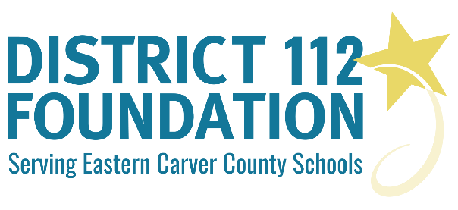

DISTRICT 112 FOUNDATION
EXCELLENCE and INNOVATION in EDUCATION
Please be creative and show us the excellence and innovation we can achieve together. Thank you for your time and effort. We look forward to considering your grant application.

GRANT APPLICATION – PART B – OUTLINE
Use these details to complete the below outline:
I. The Basics of Your Project
A. Project title (please be specific and descriptive).
B. Project objectives and/or intended outcomes.
C. Description of your project.
D. Applicant(s) credentials (i.e. degrees earned, years and locations teaching, etc.).

II. Need for Project and Benefits Expected
A. Why is this project needed?
B. What other sources of funding have you explored? Are you receiving other funding?
C. Who will benefit? Please indicate the number of students you expect to serve.
D. How will this project achieve innovation or excellence?

III. Your Budget, Timeline and Vision
A. Estimated budget for the project. Please give specific financial details. List all costs including source(s) of products/materials and attach quotes. List the most important items first. All requests must be less than $2,500. Please attach vendor quotes and financial details.
B. Project timeline.
C. Describe your vision of the completed project.
D. Describe the criteria you will use to evaluate your project upon its completion
E. If this project is intended to be ongoing, please describe sources of future funding. How will the project be supported when the grant from the District 112 Foundation ends?
F. Please describe how you plan to disseminate results of the project.
I. The Basics of Your Project
A.
B.
C.
D.

II. Need for Project and Benefits Expected
A.
B.
C.
D.

III. Your Budget, Timeline and Vision (Please provide detailed budget information (must be less than $2,500). List the most important budget items first in descending order as partial funding is likely.
A.
B.
C.
D.
E.
F.
TOTAL AMOUNT REQUESTED: $

